# REGRESSION TESTING

Testing the unchanged features to make sure that is not affected or broken because of changes is called as Regression testing (here changes can be addition, modification, removal of features or bug fixes) (OR)

Re-execution of same test case is different test cycle/ sprint/ release to make sure that changes are not introducing any defects in unchanged features (Changes can be addition, modification or removal of features) is called Regression testing

**Type of Regression testing:**

1. Unit regression testing
2. Regional regression testing
3. Full regression testing
4. ***Unit regression testing:***

Testing the changes (or) only the bugs which is fixed is called as unit regression testing.

1. ***Regional regression testing:***

Testing the changes & only the impacted regions is called regional regression testing

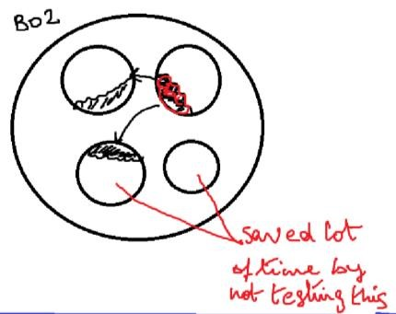

*How will you identify impacted Region?*

* 1. Based on product knowledge

As a TE in-depth I will be knowing how each & every module works & also I will be knowing how all the modules are related based on that knowledge, I will be able to identify impacted areas

* 1. By preparing Impact matrix

Here we list the changes & also all the features in the application, then mark the impacted areas.

* 1. By conducting Impact analysis meeting

As soon as the new build comes entire testing team meets & discuss about list of bugs fixed & the impacted areas

* 1. By interacting with customer, business analyst, development team, testing team we should gather the impacted areas & create an impact list, based on that we should do Regression testing

*Advantages of Regional Regression Testing:*

1. By not testing certain features we are saving testing time which internreduces the testing cost
2. Test cycle duration Reduces because of that turnaround time taken to deliver the product to the customer reduces

*Dis-advantages of Regional Regression Testing:*

*1.* Chances are there we might miss identifying the impacted area because of that we might miss the bugs.

***c) Full Regression testing:***

Testing the changes and all the remaining features is called as Full Regression testing

*Why/when we do full regression testing?*

1. Whenever too many changes are done in the product better to do full regression testing
2. If the changes are done in core features

1. Every few (4-5) cycles once we should do full regression testing & last few cycles we should do full regression testing because we are about to launch the product to the production to not to take any risk.

**What is the difference between Regression Testing and Re-testing?**

|  |  |
| --- | --- |
| ***Regression Testing*** | ***Retesting*** |
| Fixing the bugs or doing changes might have impact on other features so testing the unchanged feature to make sure that it is not broken because of changes is called as  Regression Testing | Whenever developer gives build, checking or verifying whether defect is fixed or not is called Retesting. |
| Regression Testing is done for passed test cases | Retesting is done for failed test cases |
| We go for automation | We don’t go for automation |

**Progression testing:** Testing newly added features is called as progression testing.

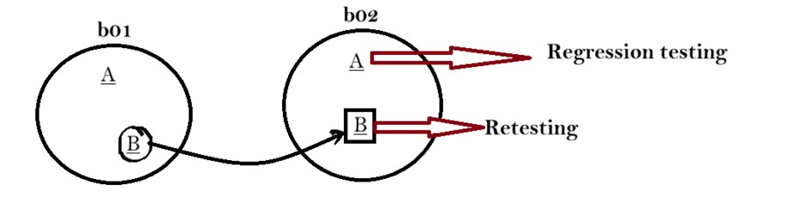

**When we do regression testing?**

* 1st release 2nd build onwards we do regression testing
* 2nd release 1st build onwards we do regression testing